**Marketing Analytics Project Report**

**The Role of Gamification in Digital Marketing Strategies**

**1. Background and Research Objectives**

**Background**

Gamification is increasingly used in digital marketing to engage customers and influence purchasing decisions. By integrating game-like elements such as rewards, challenges, and leaderboards, brands aim to foster deeper customer interaction and loyalty. However, the success of gamified campaigns depends on understanding user preferences, motivators, and behaviors. Without such insights, brands risk investing in strategies that fail to resonate with their target audience.

This project explores how gamification can be optimized for digital marketing strategies. Using segmentation analysis, we aim to uncover distinct customer groups, their engagement levels, and their preferences, which will guide actionable marketing strategies.

**Research Objectives**

1. To identify customer segments based on their preferences for gamification features, motivators, and engagement behaviors.
2. To provide actionable strategies tailored to these segments to maximize engagement and purchase likelihood.
3. To offer insights into how gamified campaigns can enhance customer satisfaction and brand loyalty.

**2. Research Method**

**Survey Design**

An online survey was designed using Qualtrics to collect data on customer preferences and behaviors related to gamification. The survey explored various attributes, including:

* Gamification Features: Leaderboards, challenges, badges, and rewards.
* Motivators: Entertainment, social competition, rewards/discounts.
* Engagement Behaviors: Frequency of participation, time spent, and preferred platforms (e.g., mobile apps, social media).

**Sample Size and Demographics**

The survey received 89 responses. The respondents varied in age, occupation, and familiarity with gamified campaigns, ensuring a diverse and representative dataset.

**Data Analysis**

The survey data was analyzed using the Enginius platform. Hierarchical clustering was applied to identify distinct customer segments based on their engagement levels and preferences. The analysis included:

1. Removing variables with high collinearity to ensure robust results.
2. Using a **dendrogram** to visualize clustering results and choose the number of clusters.

1. Determining the optimal number of clusters using a **scree plot** to identify the "elbow point." 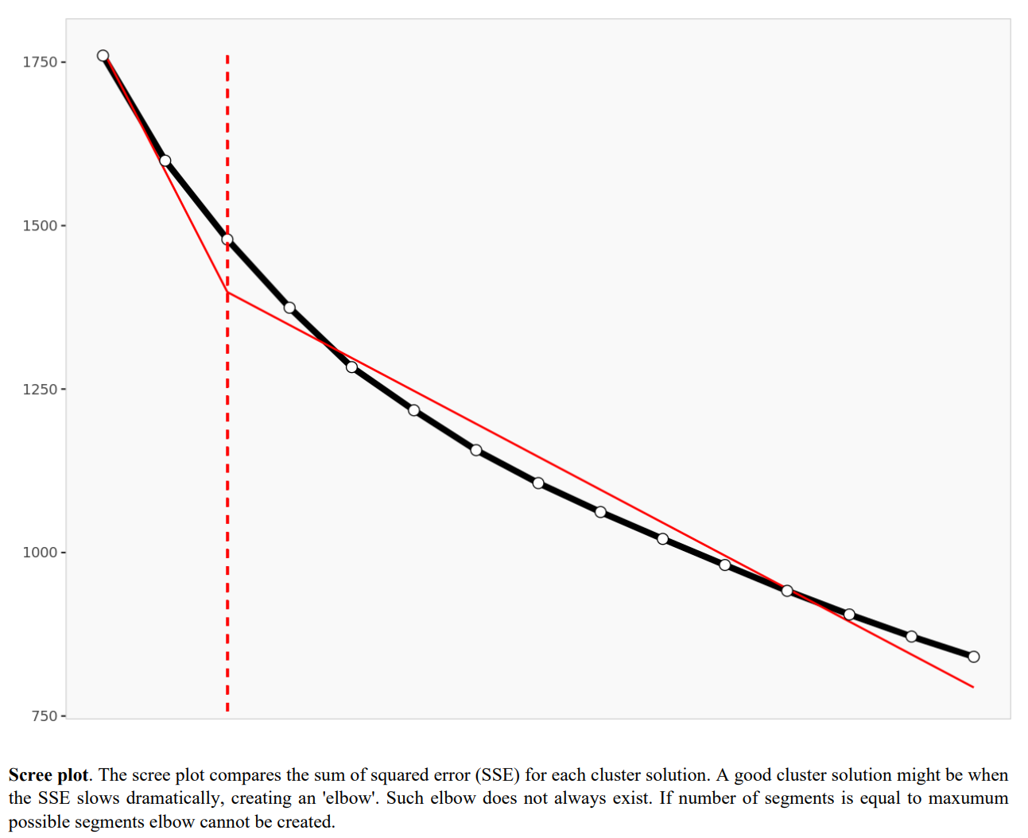

**Limitations**

1. **Sample Size**: While meaningful insights were drawn, a larger sample would increase generalizability.
2. **Self-Reporting Bias**: Responses may reflect perceived behaviors rather than actual engagement.
3. **Cluster Size**: One identified cluster (1%) was negligible and excluded from targeting considerations.

**3. Findings and Marketing Insights**

**Segmentation Analysis**

The segmentation analysis revealed three distinct customer clusters based on their engagement levels and preferences:

* **Segment 1: Casual Participants (72%)**  
  Low interaction with gamification features, minimal time spent, motivated by simple rewards.
* **Segment 2: Outlier (1%)**  
  Exceptionally high participation across all gamification features but negligible in size.
* **Segment 3: Engaged Enthusiasts (27%)**  
  High engagement, motivated by personalized experiences, and strong likelihood to purchase.

**Explanation**: The bar chart visually demonstrates the distribution of segment sizes, highlighting Segment 1 as the largest group and Segment 3 as the most valuable target.

**Key Segment Characteristics**

* **Spider Chart Analysis**

* + **Purpose**: This chart compares the average preferences and behaviors of the three segments.
  + **Key Insights**: Segment 3 shows strong preferences for personalization and advanced gamification features, while Segment 1 prefers simplicity.

* **PCA Plot (Segment Space)**
  + **Purpose**: This plot spatially represents the three segments and highlights the variables that differentiate them.
  + **Key Insights**: Segment 3 is distinctly separated from Segment 1, underscoring its unique engagement behaviors.

**Marketing Recommendations**

1. **Primary Target: Segment 3 (Engaged Enthusiasts)**
   * **Strategies**:
     + Personalization: Tailor gamified experiences to individual preferences.
     + Advanced Gamification: Implement leaderboards, challenges, and social competition.
     + Exclusive Rewards: Offer premium benefits to sustain engagement.
   * **Example Campaign**: Launch a leaderboard competition with high-value prizes and personalized notifications.
2. **Secondary Target: Segment 1 (Casual Participants)**
   * **Strategies**:
     + Simplified Gamification: Focus on basic rewards like discounts or vouchers.
     + Ease of Participation: Design low-effort campaigns to attract this group.
   * **Example Campaign**: Introduce a spin-the-wheel activity offering instant discounts or free trials.

**Conclusion:**

The findings from this project provide valuable insights into how gamification can be optimized to engage distinct customer segments effectively. Through segmentation analysis, we identified three key customer groups with unique preferences and behaviors: Casual Participants, an Outlier segment, and Engaged Enthusiasts.

Our analysis highlights that Segment 3: Engaged Enthusiasts represents the most valuable target group due to their high engagement levels and strong purchase likelihood. This segment thrives on personalized, competitive, and advanced gamification strategies. On the other hand, Segment 1: Casual Participants, while less engaged, offers significant potential due to its large size, requiring simpler gamification tactics to drive engagement.

By leveraging these insights, businesses can implement tailored marketing strategies to maximize customer satisfaction, engagement, and revenue. This project demonstrates the power of customer segmentation in informing data-driven marketing decisions and underscores the importance of aligning gamification strategies with consumer behaviors and motivators.

**Appendix: Survey Questionnaire**

**Survey Title**: The Role of Gamification in Digital Marketing Strategies

**Instructions**: Please answer the following questions to help us understand your preferences and behaviors regarding gamified campaigns.

**1. Demographics**

1. **What is your age?**
   * Under 18
   * 18–24
   * 25–34
   * 35–44
   * 45–54
   * 55+
2. **What is your gender?**
   * Male
   * Female
3. **What is your occupation?**
   * Student
   * Professional
   * Entrepreneur
   * Homemaker
   * Retired
4. **What is your income level?**
   * Less than $20,000
   * $20,000–$50,000
   * $50,000–$100,000
   * More than $100,000

**2. Gamification Familiarity and Preferences**  
5. **How familiar are you with digital marketing campaigns?**

* Not familiar at all
* Slightly familiar
* Very familiar

1. **Have you interacted with gamified marketing campaigns before (e.g., reward points, leaderboards, challenges)?**
   * Definitely not
   * Might or might not
   * Definitely yes
2. **Which gamification features appeal to you the most? (Select all that apply)**
   * Rewards (e.g., points, discounts)
   * Leaderboards/Rankings
   * Challenges/Missions
   * Badges/Achievements
3. **What motivates you to participate in gamified campaigns? (Select all that apply)**
   * Entertainment
   * Rewards/Discounts
   * Social competition

**3. Engagement Behaviors**  
9. **How often do you engage with gamified marketing campaigns?**

* Rarely
* Occasionally
* Frequently
* Most of the time

1. **What type of reward system do you prefer in gamified campaigns?**
   * Instant rewards (e.g., discounts, small gifts)
   * Accumulative rewards (e.g., points leading to larger prizes)
   * Both
2. **How likely are you to make a purchase after participating in a gamified campaign?**
   * Extremely unlikely
   * Somewhat unlikely
   * Neither likely nor unlikely
   * Somewhat likely
   * Extremely likely

**4. Platform and Personalization Preferences**  
12. **Which platform do you prefer for gamified campaigns?**  
- Mobile apps  
- Social media  
- Websites

1. **How do gamified campaigns influence your perception of a brand?**
   * Negatively
   * Somewhat negatively
   * Neutral
   * Somewhat positively
   * Very positively
2. **How important is personalization in gamified campaigns for you?**
   * Not at all important
   * Slightly important
   * Moderately important
   * Very important
   * Extremely important

**5. Additional Engagement Preferences**  
15. **How long are you willing to spend on a gamified activity?**  
- Less than 1 minute  
- 1–5 minutes  
- 5–10 minutes  
- More than 10 minutes

1. **Do you prefer gamified campaigns tailored for your age group?**
   * Definitely not
   * Might or might not
   * Definitely yes
2. **Which of the following appeals to you in a gamified campaign?**
   * Social competition (competing with friends or other users)
   * Individual achievements (earning badges or rewards)
   * Team-based collaboration (working in groups to achieve goals)
3. **Do you think gamified campaigns should be based on local culture or global trends?**
   * Local culture
   * Global trends
   * A mix of both